The Open University of Hong Kong

COMPS456F Initial Report

Dominion of City: Real Time Strategy Location-based Mobile Game

|  |  |
| --- | --- |
| Supervisor: | Dr. TS Li |
| Team: | dot |
| Member: | WONG Tik San 11181021 |
|  | LEUNG Man Him 11182527 |
|  | TANG Chi Ho 11145882 |
| Programme | Internet Technology (9717) |
| Date: | 27/10/2016 |

Content

1. Problem Definition 3

1.1 Introduction 3

1.2 Project Aim 3

1.3 Project Objective 3

1.4 Value Proposition 4

2. Literature Review 5

2.1 Lack of Entertainment 5

2.2 Virtual Games as Entertainment and Social Activity 5

2.3 Pokemon Go 6

2.4 Conclusion 7

3. Methodology 8

3.1 Game Rule 8

3.2 Major Modules 9

3.3 Development 10

Reference 12

Appendix A--Project Plan 13

Appendix B--Members’ Roles and Responsibilities 14

Appendix C--Meeting Minute 16

1. Problem Definition
2. Introduction

‘Hong Kong is a city changing rapidly. Constructions ranging from tall buildings, MTR stations to a small store are processing every day’ considered as a fact. However, Hong Kong people put focus on their own work 6 days a week, and even stuck in the mobile phone’s screen during the weekend instead of exploring the city. Indeed, the familiarity is falling behind with the modification.

Besides heavy workload and ‘nomophobic’, the short supply of the current recreation and sports facilities is also a problem, what makes the citizens lacking in motivation to step outside and have a look to their surroundings. That is one of the reasons why people cannot keep up with the community. As a result, citizens would rather tap their finger on the smartphone, which may isolates them even more from family and friends.

1. Project Aim

The aim of this project is to providing a community-based game for citizens to explore the city and extend their social circle.

There are some examples that mobile phone game maybe a new method that let people get in touch with community, latest mobile phone game can combine the real world and virtual world by new technologies like augmented reality and location-based service. They motivate the citizens to walk in the city and enjoy exploring the city.

Furthermore, we would like to let citizens enjoy meeting people on the street or having great fun and with their friends in order to strengthen the bond or widen their social circle. The project should emphasize the importance and amusement of communication and cooperation between people.

1. Project Objective

To achieve the aim, the main objective of the project is to develop an interesting game that can encourage players visit city and facilitate their social circles.

1. Attracting player to explore community
   1. Implement location based service to the game
   2. Location domination of player
   3. Performing AR-based mini game on street
2. Promoting relationship between people
   1. Implement a multiplayer online game
   2. Using bingo as one of the way to gain marks

Implement location based service to the game can combine the real world and virtual world. So the player want to walk in the virtual world, he or she must walk in the real world first. The domination of location continuing gives motivation to the player to keep jogging in the street. AR-based mini game increases the difficulty in the domination because the game content maybe related to community. Those are the point that attracting player to keep exploring the community more through the game.

Moreover, implementing multiplayer online game increase the chances for player to get in touch with others. Players need to cooperate well to dominate a proper location to gain a high marks to win the game. In addition to it, bingo is also a way for the player to gain marks. It is quite impossible for one person to bingo, it requires the effective cooperation between teammates to bingo!

1. Value Proposition

For teenagers who are finding an interesting and special mobile phone game our game is combining the real world and virtual world that spark the interest of player to explore the community and encourage them to widen their social circle. There is just a few kinds of these games so it might be innovative and inspire more idea of combining reality and virtual world.

1. Literature Review
2. Lack of Entertainment

One of the problems is lacking in entertainment. Take the recreation and sports facilities under the Leisure and Cultural Services Department as an example, the venues are being speculated in for making personal benefit. The Office of the Ombudsman (2012, 10) points out that Speculation makes the general public more difficult to reserve facilities. As a result, people lacking in motivation to step outside and have a look to their surroundings.

1. Virtual Games as Entertainment and Social Activity

Virtual games provide entertainment and build strong relationships between players effectively and efficiently by easily creating virtual element and letting players interact frequently.

The main motive of playing games is the social network and social satisfaction. According to Teng, Huang and Chen (2015), intensive interaction during gaming form social connection and encourage continuance of gaming. A major need human being, social needs can force gamers to build deep relationship and exchange information to build interdependence, which is the degree of how individuals depend on each other in a relationship (p. 14-16). This is obvious in some games which provide guild function that let players form an organization. Such kinds of community in games assist players to share resources like goods or consultant which is internal social capital (Hsiao & Chiou, 2012, p. 81-82). It causes a higher loyalty to the community and the game. When gaming with strangers or players outside the internal social capital, players still gain positive feeling of mysterious adventure (Snodgrass, Lacy, Dengah & Fagan, 2011, p. 1217) which is instantly enjoyable and they could make new relationships.

Furthermore, games always reward players with scores, experience points, items and so on. Utilizing the reward for advancement, review, sociality, cooperation and competition, players gain satisfaction by flaunting and anticipating next rewards. As a result, they are increasingly willing to learn and spend time on the game (Wang & Sun, 2011, p. 6-9).

Some are afraid that online game may cause addiction harmful to physical and social health but Snodgrass, et al. (2011) argued that playing with real-life-friends can prevent problematic use of games by monitoring and reminding each other. Relationship, pleasure of game and social well-being are positively related (p. 1219).

Wang and Sun (2011) suggested the following:

Physical world activities: Reward systems with support of mobile technology have been used to encourage a range of activities; from shopping, traveling, even to taking exercise. The idea of making players have more physical contact and do something good for health have made more people willing to play or feeling less guilty on playing games; just like Wii has changed the image of game playing. (p. 13)

1. Pokemon Go

There are some related existing solutions. Pokemon Go is one of them. In this July, Pokemon Go keeps release in different countries and getting popular in the world. They getting more than 20 million times download in first week. (Cranfrod, 2016) Its trend only keep in a short period, but it shows a new way of game. It use augmented reality technology to combine the reality world and game world. Although it is not an essential function in the game, it attracts people to play it. Pokemon Go also uses the Location Based Service . If player want to move in the game world, he need to move in the real world first. Therefore, if there are some rare pokemon appears, many people will walk or even run to that location. It is success and there are many people walking and catching the pokemon in the street. (Cranfrod, 2016)

Pokemon Go also has social benefits, players will meet together by the street, Pokemon Go gives them a chance to communicate. Some players also expressed that if he does not playing it socially, he would not really play it. (Barker, 2016). So that social communicate maybe also one of the motivation to play mobile games.

1. Conclusion

Citizens in Hong Kong are lacking intension to go out to explore the city, but mobile games have the potential to spark their interest and form a habit to move around the city. Current solution Pokemon Go was popular and remarkable with news telling that players are rushing for pokemon around the whole world. However, it is not related to community, player only go out to the street and catching the pokemon. It cannot promote the community to the player. Therefore, a new game that closely related to community is needed. Moreover, the player communication is not an essential element when they are playing the game. As a result, it cannot extend the social circle of player a lot. There should be a mobile game that relates more to city by asking player to walk through the city and pay attention to the surrounding. Besides, the game should let people communicate more by cooperative task and enjoy working together on an aim.

1. Methodology
2. Game Rule

To drive citizens to step out to the street and meet other people, this project will create a mobile game. The game, Dominion of City, is to occupy spots in the city to gain points or win the bingo. Users have to create account and open a room for 2 teams of players to race against each other. After randomly create a bingo for the spots, players have to head to those places and occupy them by playing an augmented reality mini game. The spots will provide scores for the team that occupy them. When the time is up or one of the team form a straight line on the bingo, extra points for the bingo winner are rewarded and the game is ended. The team with higher score will win this game. 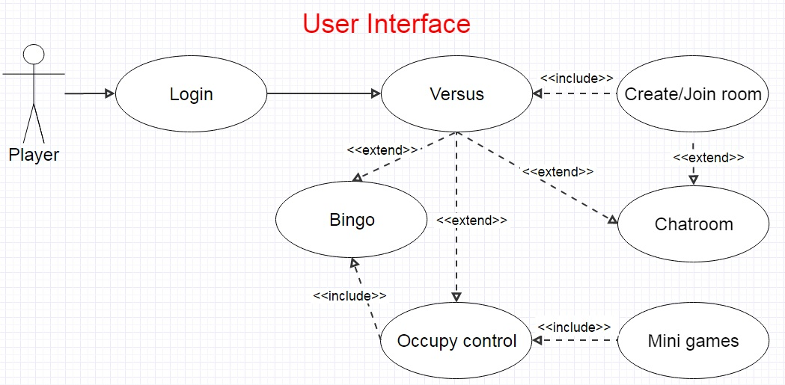

Figure

1. Major Modules

There will be a lobby containing rooms. 6, 8, or 10 players to form a game equally divided into 2 teams.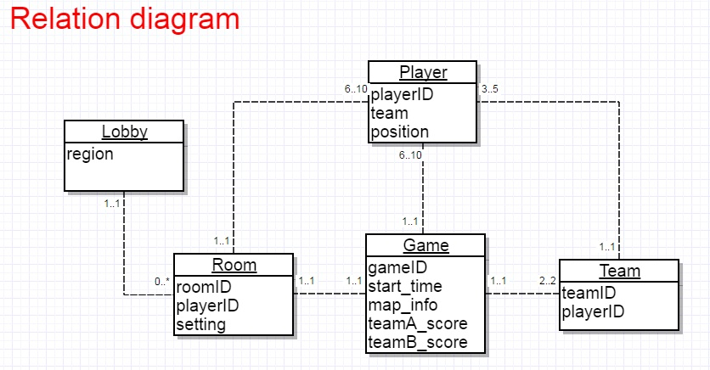

Figure

1. Development

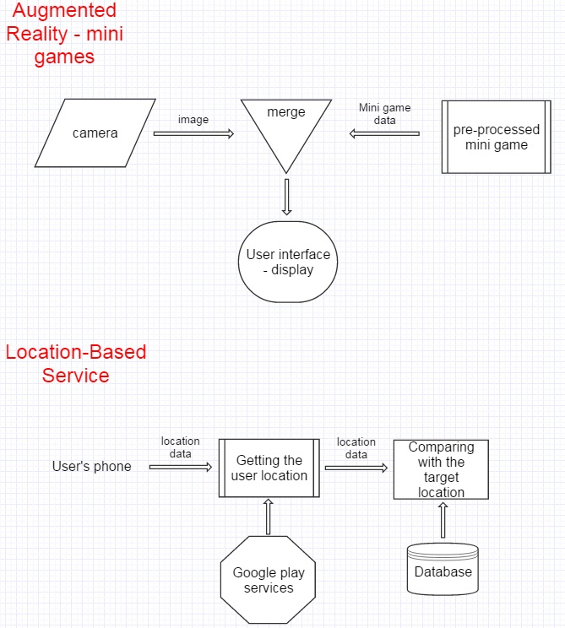This project will be a location-based mobile game on Android operating system. It will be developed by Android Studio to create user interface (figure 4) and apply Vuforia to create augmented reality mini game (figure 3) which request players to stare at the camera in order to occupy the spot. To accomplish the location-based function (figure 3), Google play services are also needed. User and location information will be store at an Apache database.

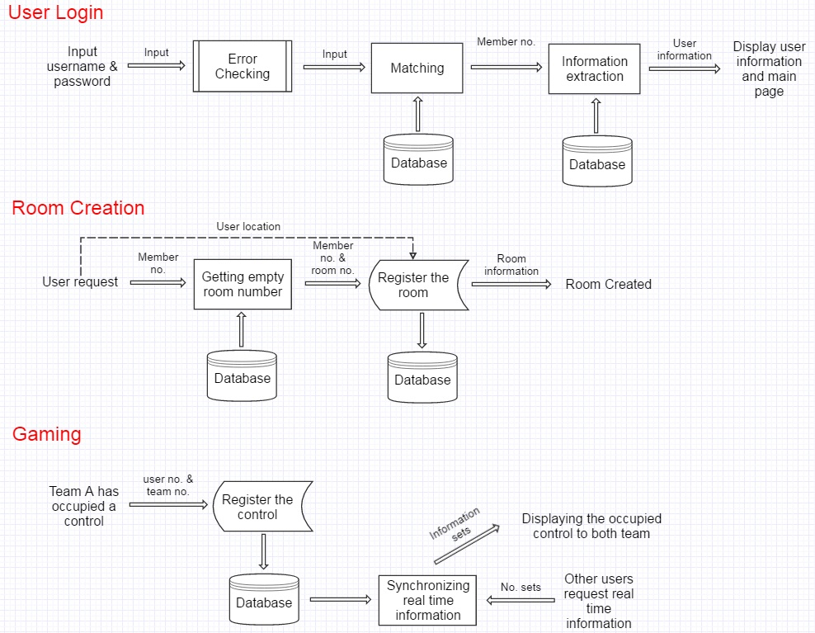

Figure

Figure

# Reference

Barker, S. (25 Aug 2016). *Student play’Pokemon Go’ for physical, social benefits* Retrieved from <http://search.proquest.com.ezproxy.lib.ouhk.edu.hk/docview/1814002575?rfr_id=info%3Axri%2Fsid%3Aprimo>

Cranford, R. (25-31 Jul 2016). *‘Pokemon Go’ and Social Marketing* Retrieved from <http://search.proquest.com.ezproxy.lib.ouhk.edu.hk/docview/1810255881?OpenUrlRefId=info:xri/sid:primo&accountid=16720>

The Office of the Ombudsman, Hong Kong (2012) *主動調查報告 康樂及文化事務署 體育設施的預訂和使用*, Hong Kong: The Office of the Ombudsman.

Teng, C. I., Huang, H. C., & Chen, J. L. (2015). Social Networking and Continuance Intention among Online Gamers. *臺大管理論叢*, *25*(2), 1-22.

Hsiao, C. C., & Chiou, J. S. (2012). The effects of a player’s network centrality on resource accessibility, game enjoyment, and continuance intention: A study on online gaming communities. *Electronic Commerce Research and Applications*, *11*(1), 75-84.

Snodgrass, J. G., Lacy, M. G., Dengah, H. F., & Fagan, J. (2011). Enhancing one life rather than living two: Playing MMOs with offline friends. *Computers in Human Behavior*, *27*(3), 1211-1222.

Wang, H., & Sun, C. T. (2011, September). Game reward systems: gaming experiences and social meanings. In *Proceedings of DiGRA 2011 Conference: Think Design Play*, 1-12.

# Appendix A--Project Plan

# 

figure 5

# Appendix B--Members’ Roles and Responsibilities

* + Team Coordinator, Secretary: Dixon Wong
  + Database Expert: Tim Leung
  + AR Expert: Dixon Wong
  + GPS Expert: Toni Tang
  + System Analysis & Design: Dixon Wong, Tim Leung, Toni Tang
  + Programmer: Dixon Wong, Tim Leung, Toni Tang
  + Tester & Evaluator: Dixon Wong, Tim Leung, Toni Tang

|  |  |  |
| --- | --- | --- |
| **Category** | **Tasks** | **Responsible** |
| Technology Test | Vuforia | Dixon & Tim |
| Technology Test | GPS | Toni |
| Server | Point Location Management | Toni |
| Server | Bingo of Points Generation | Toni |
| Server | Point Occupation | Dixon |
| Mobile Application | Game Information Acquisition | Toni & Tim |
| Mobile Application | Point Information Acquisition | Toni |
| Mobile Application | Occupation Information | Dixon |
| Mobile Application | Score Acquisition | Tim |
| Mobile Application | Game Over | Tim |
| Mobile Application | Point Occupation | Dixon |
| Mobile Application | AR Mini Game | Dixon |
| Server | Database Setup and Maintenance | Tim |
| Server | Score Counting | Tim |
| Server | Game Judgement | Tim |
| Mobile Application | Graphics Desgin | Toni |
| Mobile Application | New Game Creation | Dixon |
| Mobile Application | Participation | Dixon |
| Mobile Application | Chat Room | Dixon |
| Server | New Game Creation | Dixon |
| Server | Participation | Dixon |
| Server | Chat Room | Dixon |
| Mobile Application | User Account | Dixon & Tim |
| Mobile Application | User Login | Dixon & Tim |
| Mobile Application | User Register | Dixon & Tim |
| Server | Account and User Data Management | Dixon & Tim |

figure 6

# Appendix C--Meeting Minute

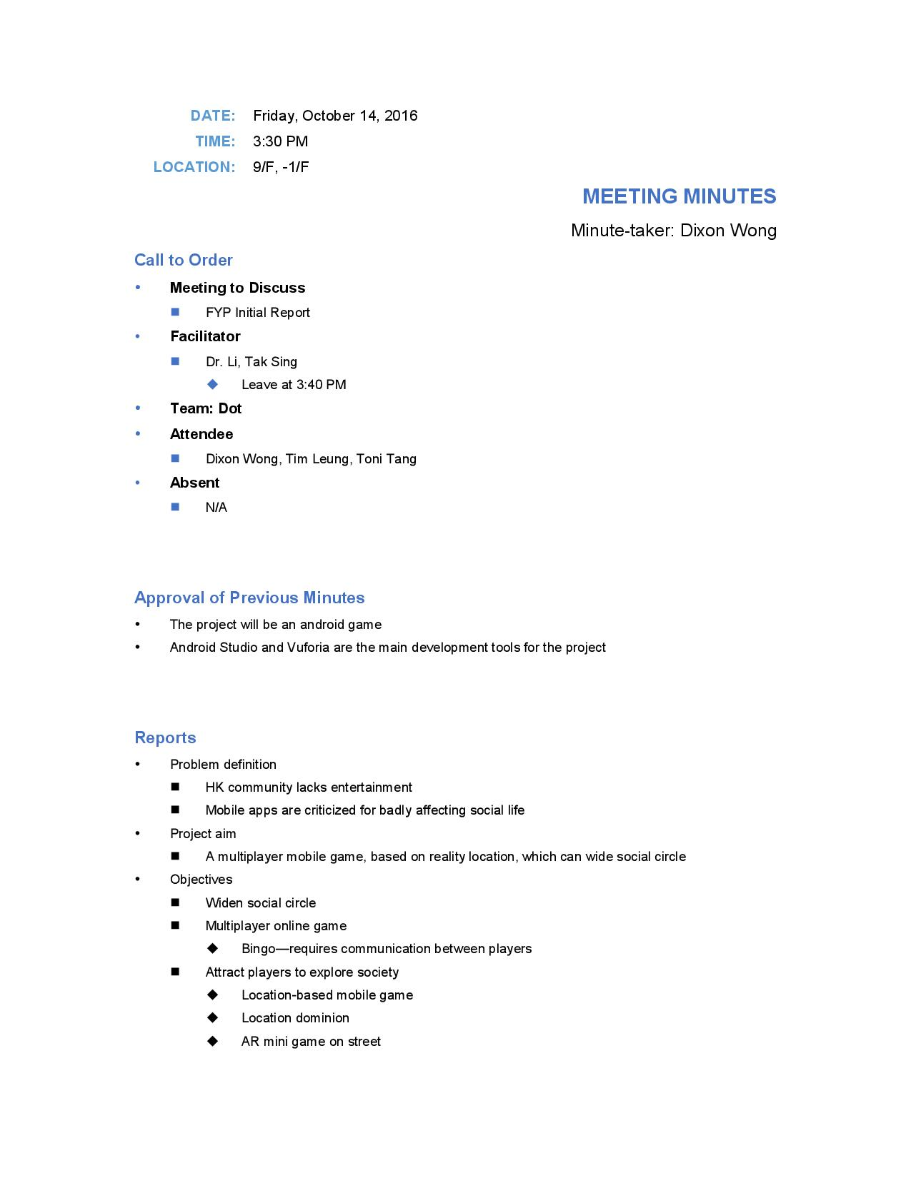

Figure 7

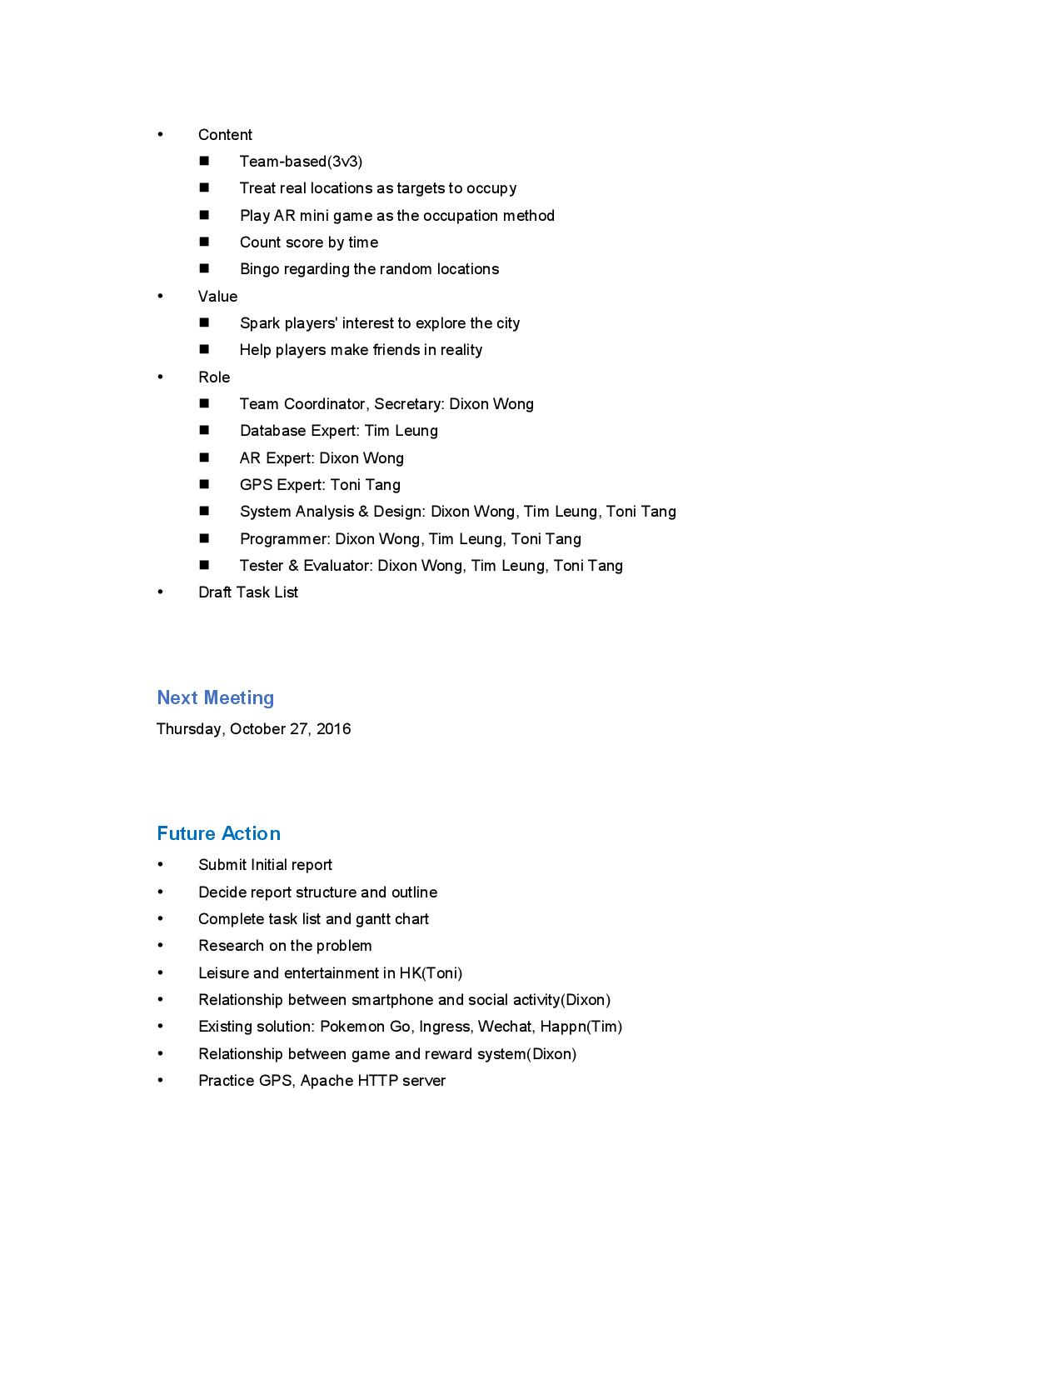

Figure 8